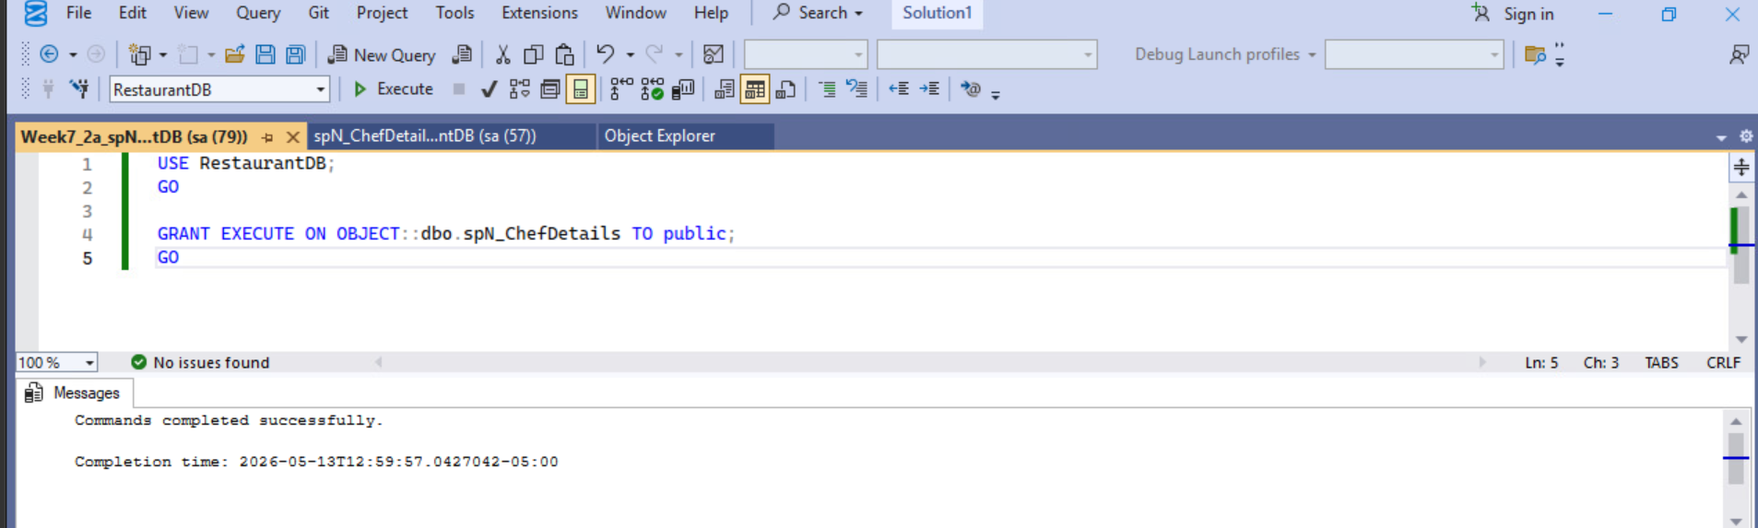

Script 2a
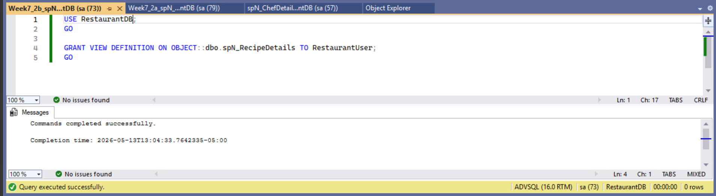
Script 2b
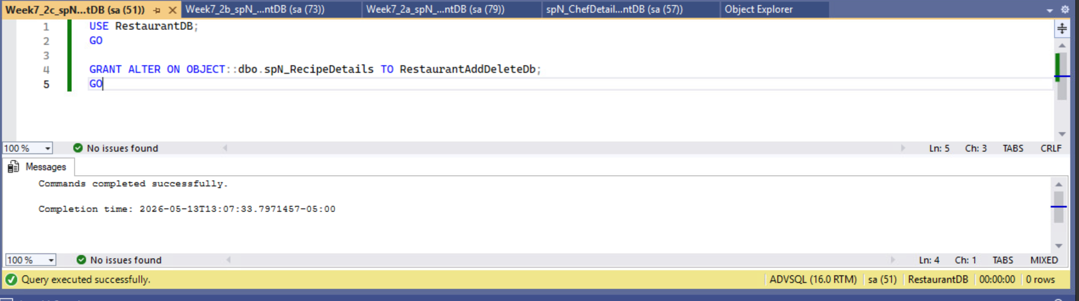
Script 2c
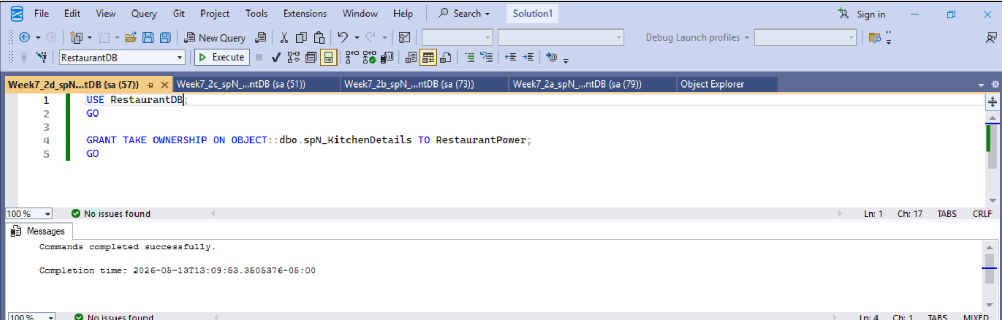
Script 2d
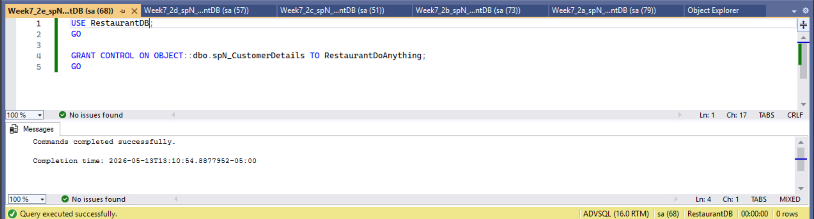
Script 2e

